Advanced cOmputer ARchitectures
2026
Practical Session III

Cache Memories

This guide uses the Ripes Simulator. To this end, each student must install this tool on their personal computer, according to the information available here.
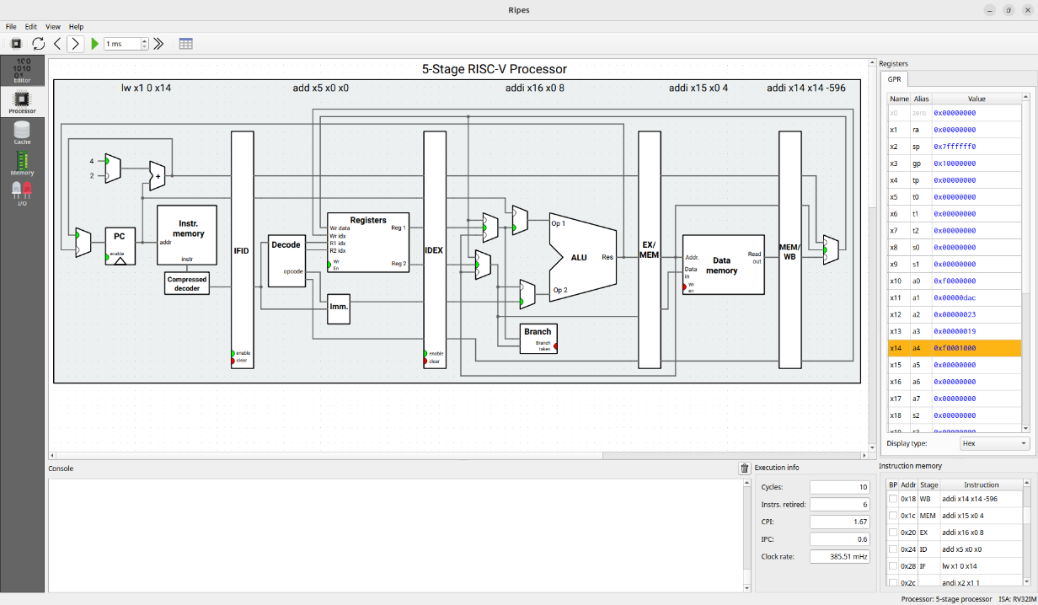
Besides the information available in this guide, it is recommended that you also read the information available in the simulator’s website, to ensure a better understanding of its functionality.

Practical Session III – Summary

This Practical Session is divided into two parts:
- Part 1 – Ripes Simulator – Cache Memories
- Part 2 – Practical Session Exercises (provided during the class session)

Part 1 is provided in this document and should be done by the students ahead of the class to prepare the Practical Session. These include tutorials to explore the functionalities of the Ripes Simulator, while reviewing the topics discussed in the classes about Cache Memories. One source file (p3_home.s) is provided together with this guide.

Part 2 will be provided in the beginning of the next class and then solved by the students. The exercises will be solved in the first two 45-minute periods of the class, followed by a review and discussion in the last 20 minutes.

The answers to both Part 1 and Part 2 must be submitted until Friday, April 17, 11:59pm, through the following QR code.


REMEMBER: All the RISC-V instructions covered in the theoretical and practical classes are described in the RISC-V Reference Card, already provided to the students. It is not necessary to memorize the instructions, just understand and consult the Reference Card whenever necessary (including at any time during assessment).

Part 1 - Ripes Simulator – Cache Memories

Perform the following steps.

Select processor architecture
The toolbar at the top allows you to choose different processor architectures to simulate your code.
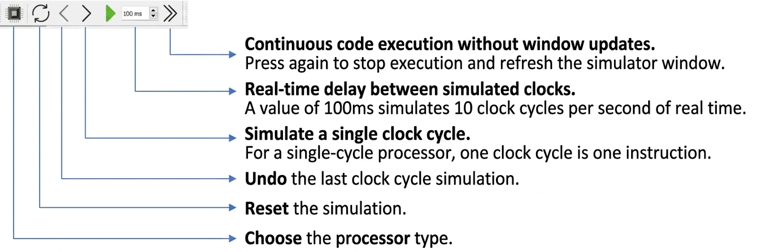
Click on the symbol to “Choose the processor type” as shown in the image above. This will open a menu that will allow you to select different processor architectures. In this practical session, we will only use the “Single-cycle processor” under RISC-V32-bit. Select the options highlighted in the image for “ISA Exts.” (only M) and “Layout” (Standard).
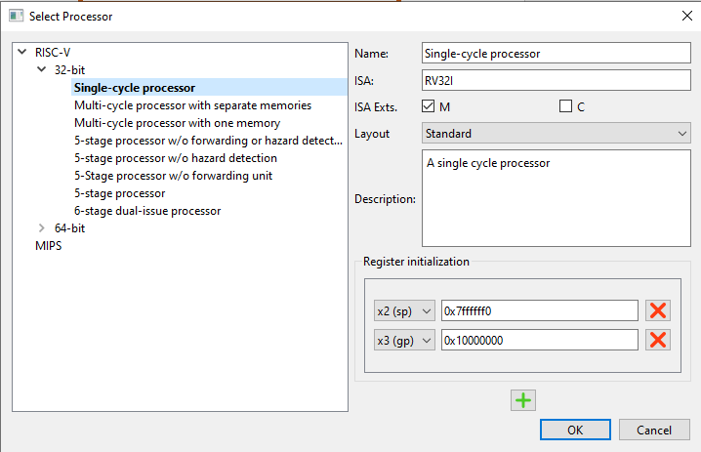

Configure cache and memory
In addition to simulating different processor architecture models, Ripes also includes a cache memory simulator, allowing users to study the behavior of this memory component in response to the address patterns (instruction or data) required by the application.

To ensure a thorough understanding of the features and operation of this cache simulator, we recommend reading the relevant documentation, available at the following web page: https://github.com/mortbopet/Ripes/blob/master/docs/cache_sim.md

In particular, the cache simulator allows for the definition of a wide range of configuration parameters, namely:
- The number of lines (sets) in each way;
- The number of cache ways;
- The line size, which is specified based on the register size. In particular, the line size is indicated in words per line, where in this context 1 word corresponds to 32 bits in RV32;
- The replacement policy (only for associative caches) – Repl. Policy;
- The write policy (Wr. hit) and data allocation (Wr. miss) in the cache in the case of a store;
It also allows counting the number of Hits and Misses, as well as calculating the resulting Hit-Rate, as the program is being executed by the processor.

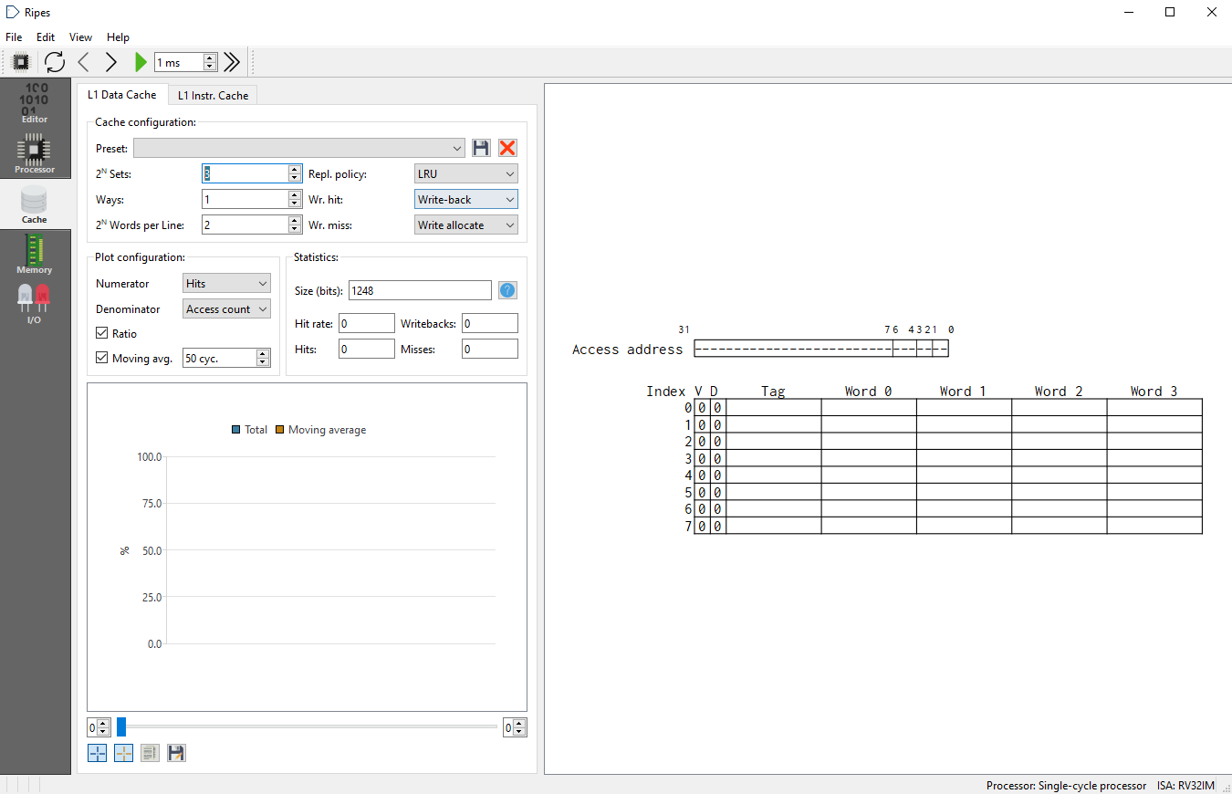

Load the example program
Select “File” followed by “Load Program” from the menu bar, select “Source file” and the “p3_home.s” file provided with this guide.

In this practical session, we will examine the influence of the cache on the average access time to data in the memory hierarchy associated with a given processor. In particular, we will consider the implementation of a matrix-vector multiplication operation:
$$y=A.x$$
In this equation, A is a NxN matrix and y, x are N-element vectors. All operands are 32-bit integers. To do so, the following C program was translated to RISC-V Assembly in the “p3_home.s” file provided with this guide.
for (i=0, checksum=0; i<N; i++){
sum = 0;
for (j=0; j<N; j++){
sum += A[i][j]*x[j];
}
y[i] = sum;
checksum += sum;
}

Cache architecture analysis
Suppose the program runs on a set of fixed-size matrix (NxN) and vectors (N), where N=16. Each element stores a 32-bit integer.
Assume that matrix A is allocated in memory using the row-major-order format, with element A[0,0] stored at address 10000000h and element A[0,1] stored at address 10000004h. The matrix A and both vectors are allocated in adjacent memory spaces (i.e., first A, then x, then y).
Determine the values of the addresses (in hexadecimal) of the following elements of the matrices used throughout the program’s execution:

Element | Address (Hexadecimal)
A[0,15] | 0x1000003C
A[1,0] | 0x10000040
A[7,11] | 0x100001EC
x[7] | 0x1000041C
y[7] | 0x1000045C
Now consider the use of a memory system consisting of a data cache (L1) and main memory (DRAM), with the following characteristics:

RISC-V
Processor
L1 Data Cache
DRAM

L1 Data cache
Number of ways: | 1
Number of lines: | 32
Line size^{(see note)}: | 16B (4 words)
Replacement Policy: | Least Recently Used
Write Policy: | Write-Back
Allocation Policy: | Write-Allocate
Access time (t_{Hit}): | 1 ns
DRAM
Total size: | 1 GByte
Access time: | 100 ns

Note: Since the processor has been configured in 32-bit mode (RV32), the simulator defines the row size in terms of 4-byte words.

Based on the specification described in the previous paragraph, and assuming a 32-bit address bus, determine the number of bits associated with the tag, index, and offset for each address fetched by the processor. Justify bellow by showing all the necessary calculations.
Tag | Index | Offset
23 | 5 | 4
(1) :Offset bits =log2​(Line size)=log2​(16)=4 bits
(2): Index bits =log2​(Number of lines)=log2​(32)=5 bits
(3): Tag bits =32−Index bits−Offset bits=32−5−4=23 bits

Determine the tag, index, and offset values of the addresses of the following array elements:
Element | Address (Hexadecimal) | Tag | Index | Offset
A[0,15] | 0x1000003C | 0x80000 | 0x03 | 0XC
A[1,0] | 0x10000040 | 0x80000 | 0x04 | 0X0
A[7,11] | 0x100001EC | 0x80000 | 0x1E | 0XC
x[7] | 0x1000041C | 0x80000 | 0x01 | 0XC
y[7] | 0x1000045C | 0x80000 | 0x05 | 0XC

Analyze cache behaviour
Open the Cache simulator view that allows you to observe the operation and usage of the cache memory. Configure the cache according to the specification defined in 4, in table named L1 DATA CACHE. Notice that the number of sets (lines) and the number of words per line must be provided in the format 2^{N}.
Run a few clock cycles to observe the fill and access criteria for the first memory accesses.
Run the program to the end by pressing the >> key in the simulator.
Observe and interpret the result by examining the various regions of the data memory (.data section) to identify the addresses that store the vector (y) containing the function’s result.

Fill in the following table:
No. of Hits: | 402 | Total No. of Memory Accesses: | 528
No. of Misses: | 126 | Miss-Rate (total) [%]: | 23.86%

Given the memory system defined in 4, determine:
Average time for each data access [ns]: | 24.62ns
Total data access time [ns]: | 12999.36 ns

Compare the obtained values with those that you would obtain if the memory system did not include a cache (i.e., all accesses would be made directly to memory):
Average time for each data access [ns]: | 100ns
Total data access time [ns]: | 52800 ns

Part 2 - Ripes Simulator – Cache Memories (Class)

Perform the following steps.

Cache parameterization study
Continue analyzing the “p3_home.s” program. Now vary the cache parameters by increasing the number of ways to 2, 4, and 8, while keeping the total cache capacity (i.e., decreasing the number of line) and keeping line size constant. Record in the table how the total miss rate changes as a function of the number of ways:
No. of ways: | 1 | 2 | 4 | 8
No. of lines (sets): | 32 | 16 | 8 | 4
Line size: | 16B | 16B | 16B | 16B
Miss-Rate (total) [%]: | 23.86% | 13.64% | 13.64% | 13.64%

Given that the number of paths increases cache access time, which configuration would you choose?
The 2way configuration reduced the miss rate from 23.86% to 13.64%, effectively eliminating most conflict misses for this matrix multiplication workload.
Increasing the ways further to 4-way or 8-way did not improve the miss rate (it remained at 13.64%), meaning there is no additional performance benefit. Higher associativity (4way/8way) increases hardware complexity, tag comparison latency, and power consumption, which is not justified by the saturated performance.
Therefore, the 2-way configuration provides the best balance between low miss rate and fast access time.

Now vary the line size to 8B, 32B, and 64B, while keeping the total cache capacity and the number of channels chosen in the previous step. Record in the table the results in terms of the total miss rate as a function of line width:

Selected no. of ways: | 2 | 2 | 2 | 2
No. of lines (sets): | 32 | 16 | 8 | 4
Line size: | 8B | 16B | 32B | 64B
Miss-Rate (total) [%]: | 23.86% | 13.64% | 13.64% | 13.64%

Large problem size study
Consider the optimal line size configuration obtained in section 1. Now change the dimensions of matrix A from 16x16 to 64x64 and of vectors x and y from 1x16 to 1x64. To do this, load the file “p3_class.s” (which sets N=64). Repeat the steps in section 1 with the new program (N=64) and comment on the obtained results.
No. of ways: | 1 | 2 | 4 | 8
No. of lines (sets): | 32 | 16 | 8 | 4
Line size: | 16B | 16B | 16B | 16B
Miss-Rate (total) [%]: | 56.40% | 14.14% | 14.90% | 16.42%

Selected no. of ways: | 2 | 2 | 2 | 2
No. of lines (sets): | 32 | 16 | 8 | 4
Line size: | 8B | 16B | 32B | 64B
Miss-Rate (total) [%]: | 26.73% | 14.14% | 7.84% | 4.69%
From 1way to 2way, the miss rate reduced a few steps from 56.40% to 14.14%, but when we increase to 4-way/8-way, it shows that no benefit with only a slight change have happened.
The optimal line size for this workload is 64B, which achieved the lowest miss rate of 4.69%.
The best overall cache configuration for the N=64 workload is 2way set-associative with 64B line size.

https://github.com/mortbopet/Ripes

